Project Title:
Heritage Treasures: An In-Depth Analysis of UNESCO World Heritage Sites in Tableau
Team ID: LTVIP2026TMIDS89796
Project Design Phase-I
Solution Fit
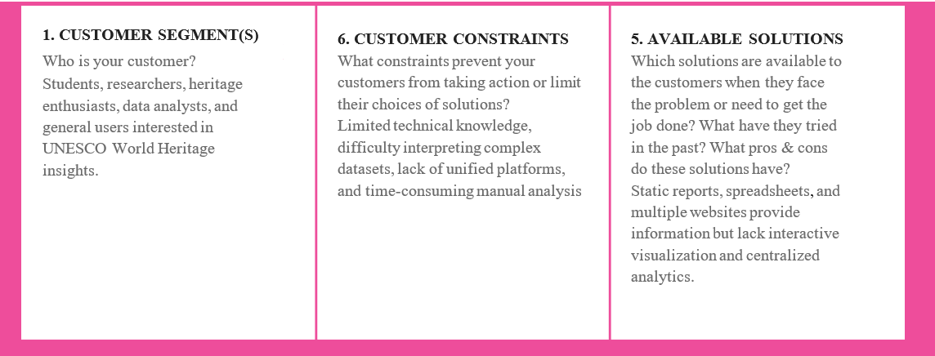
Focus on J&P, tap into BE, understand RC
